|  |
| --- |
| SmartBus App tutorial |
| the mobile client side image show |
| This is a project of SmartBus. This part consists of two parts: one is Android Mobile Client Application. The other is Java EE server for dealing with the data processing in the SQL database. This tutorial is to show how to use our app on Android smartphones. ---Stella |

5/24/2016

SmartBus App tutorial

the mobile client side image show

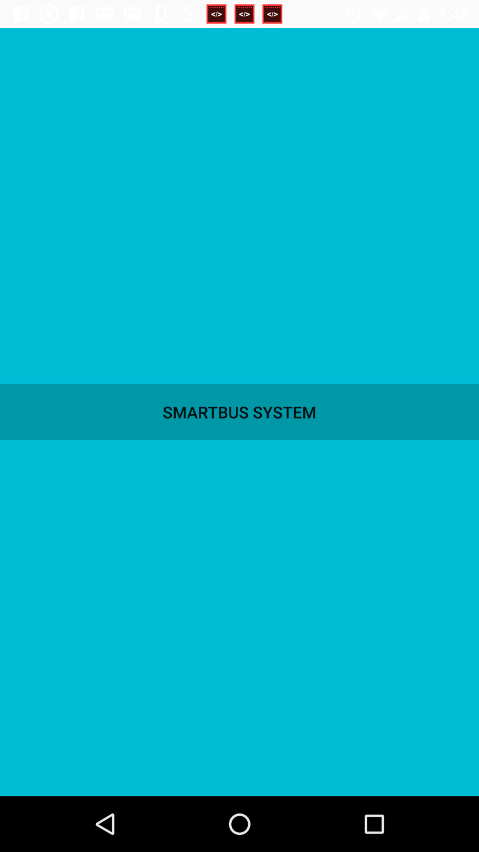

First view of our app

This is the first view of the smartbus app. You may add more option links on this view. When you click the smartbus system button, it will show the next view, which is the main view of our app.

Main view of our app

This is the main view of the smartbus app. You can choose the origin route, origin direction, origin stop, destination route, destination direction and destination stop from the right lists. If you choose different route, the related direction and stop will be changed along with it. If you have chose your origin and destination, you can click the submit button and the data will be sent to the database through our JavaEE Tomcat Server.

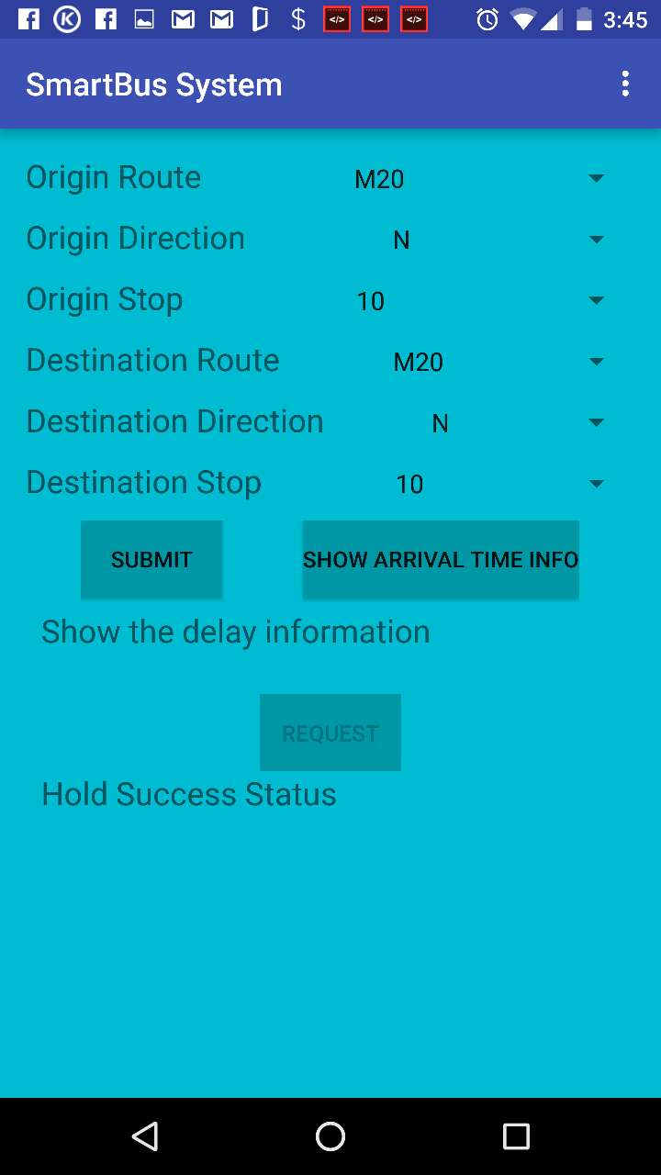

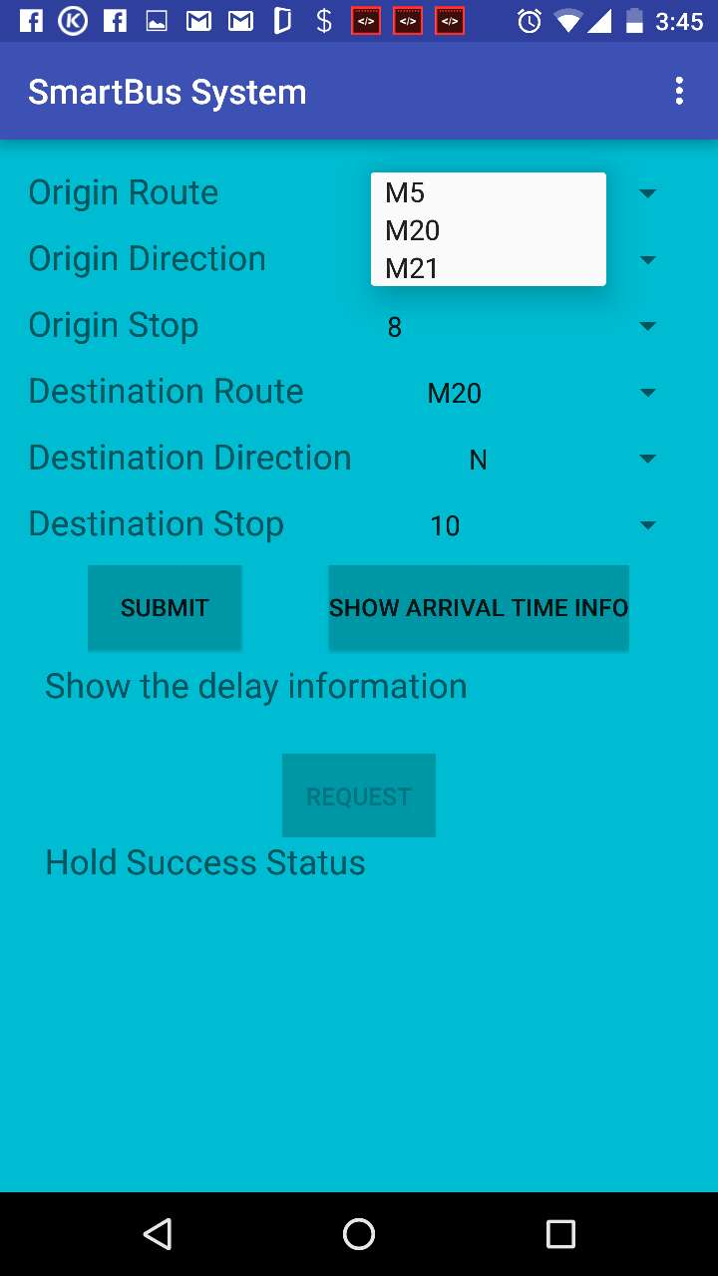

Main view of our app

For example, you can choose origin route M5 here as the image shows.

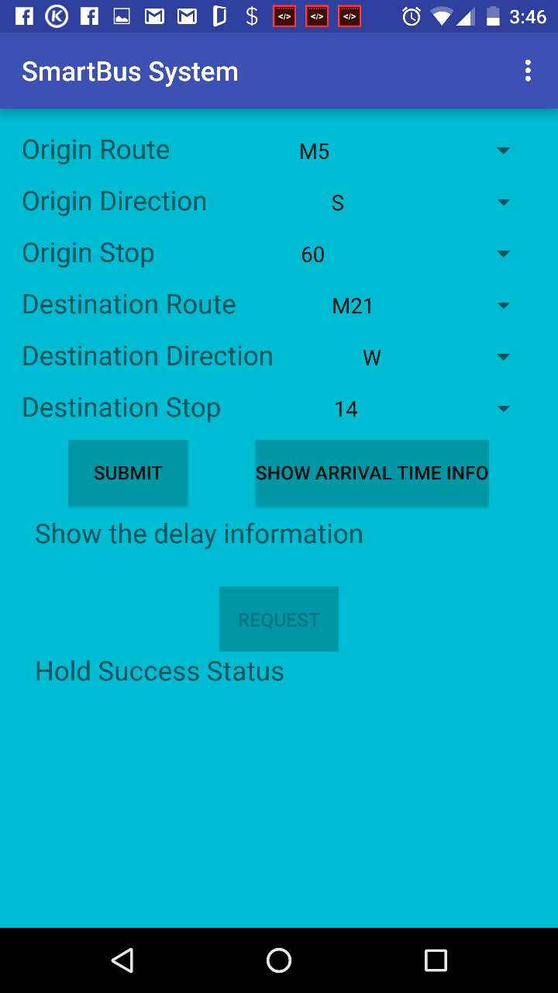

Main view of our app

For example, you can choose origin route M5 here. And then you choose origin direction S, origin stop 60, destination route M21, destination direction W and destination stop 14 as the image shows.

origin route, origin direction, origin stop, destination route, destination direction and destination stop

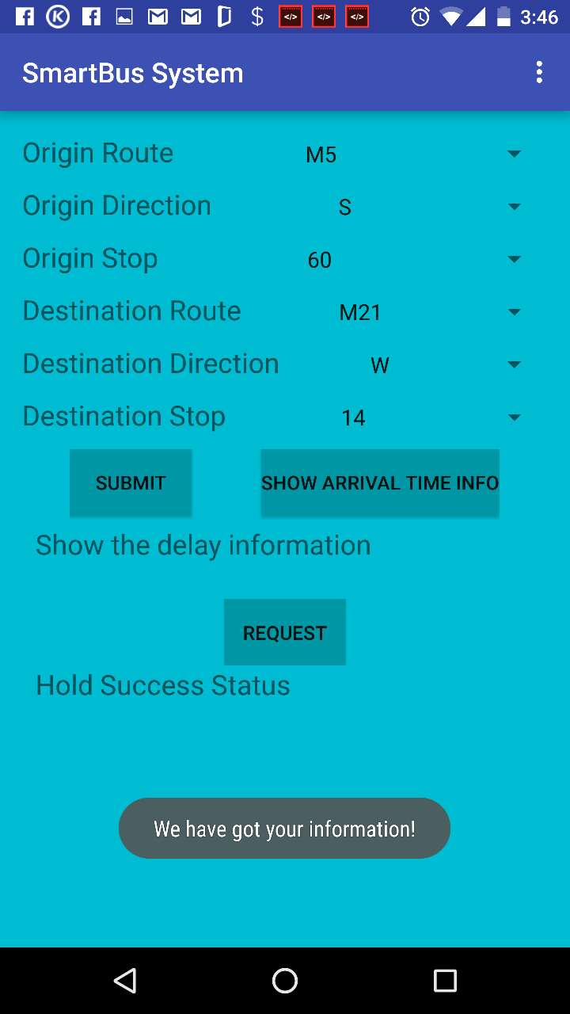

Main view of our app

After you selected from the lists on the right side, you can click the submit button to send your data through server to the database. Then the app will tell you that “We have got your information” since here we are connected with the server. But if the server is not accessible, it will show “Sorry. Fail to connect server. Please try later.”.

Main view of our app

After you clicked submit button, you can click “Show arrival time info” button to show the arrival time information. Then “Show the delay information” will change to the information we requested from the server. This part will show the current bus arrival time and the next bus arrival time at the transfer stop.

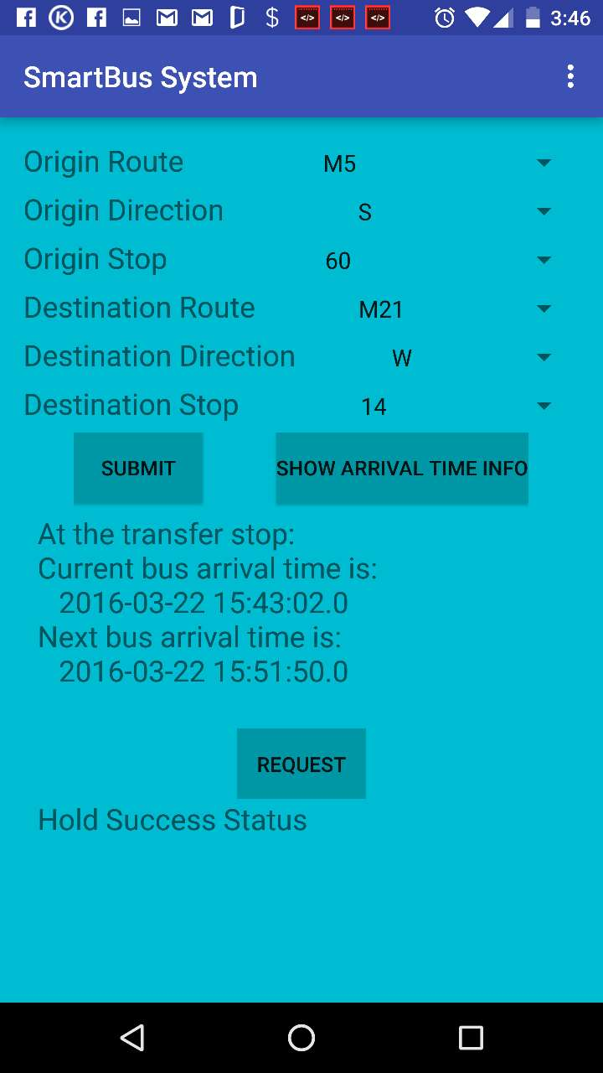

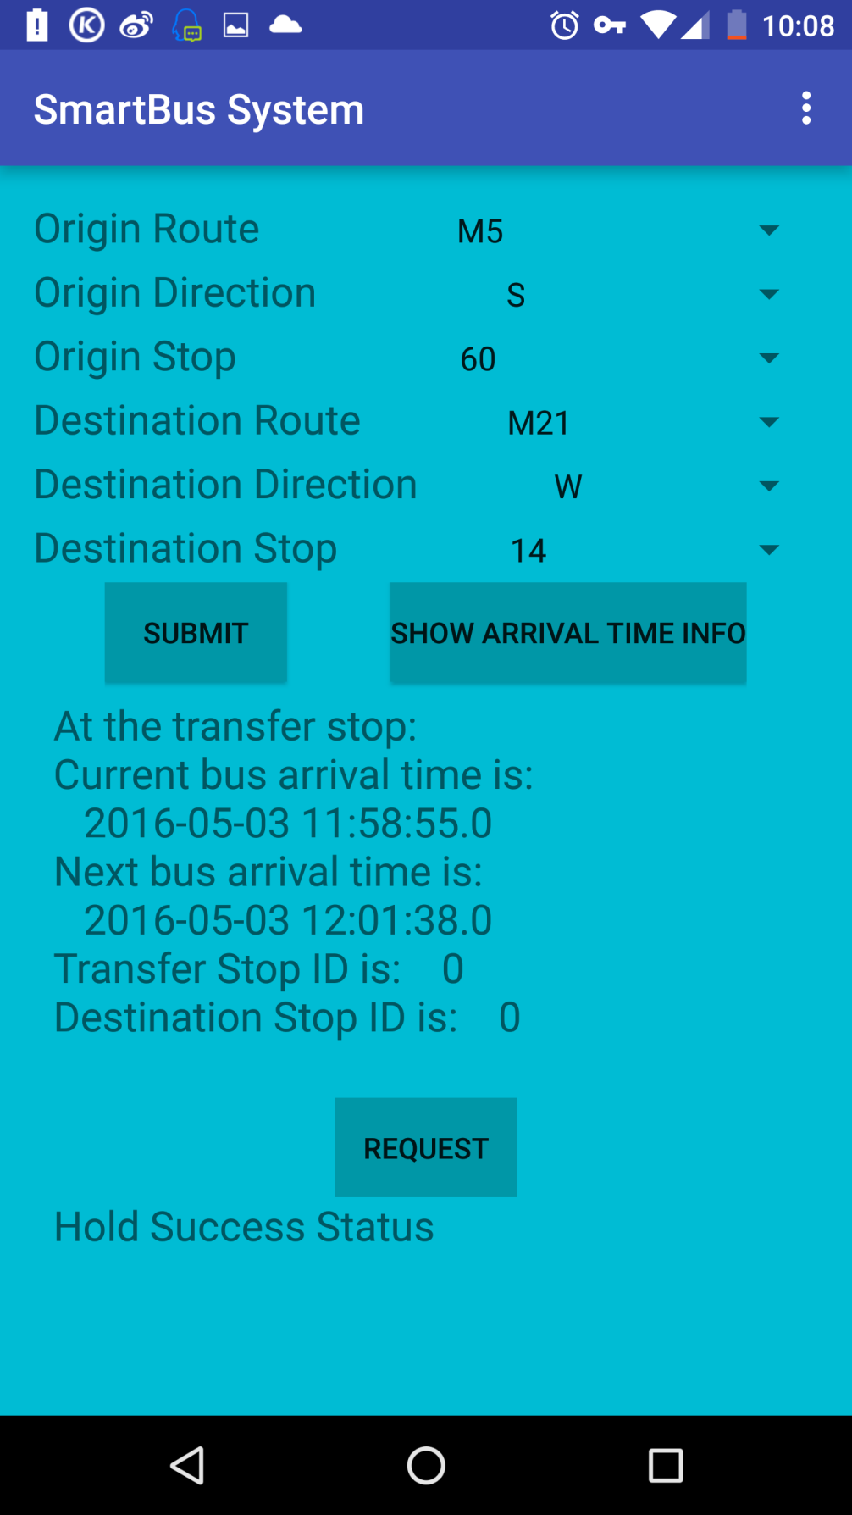

Main view of our app

This is the update version. It can show not only the arrival time information, but also the transfer stop id and destination stop id.

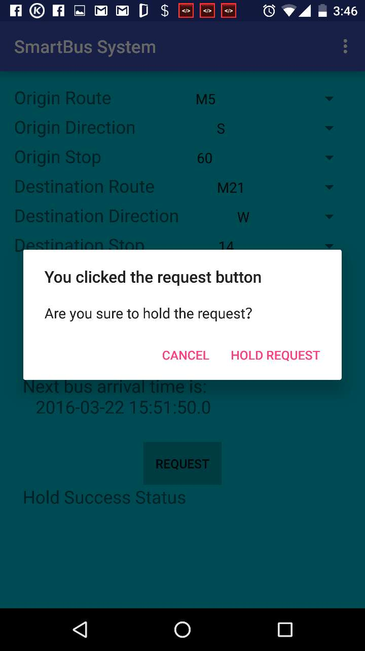

Main view of our app

If you want to hold the request (to request the transfer bus and let it wait for you), you can click the “request” button at the bottom. An then a popup window shows up and ask you whether you are sure to hold the request. Since sometimes we may click a wrong button with no intent. With this we can avoid the unnecessary touch from the user. If you are sure, then you can click the “Hold Request” button on this window.

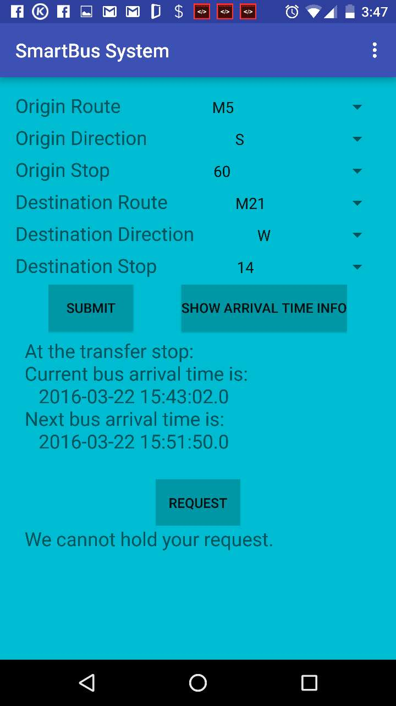

Main view of our app

After you click the “Hold Request” button, you will find that “Hold Success Status” will be updated to “We cannot hold your request”, which means that you can catch the next bus since there is an interval time period between current bus arrival to the next bus coming time. So it is no need to hold your request. Thus we cannot hold your request. If the request is accepted (you cannot catch the next bus but the interval time is very small), this will show “Success hold your request”.

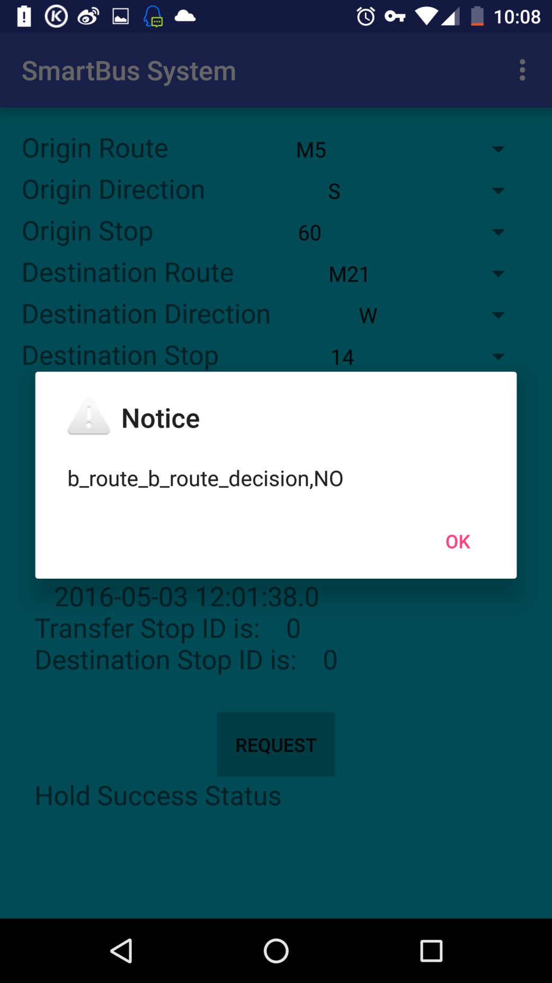

Main view of our app

We will update the route information from the user click the “submit” button to send the route information. We update the route information every 20 seconds. When the route is changed, there will be a popup window shows related route change information. You can click “ok” to close this window. We update the information in the window directly to avoid the redundant windows.